# Business Challenge

Organizations often staff projects with available resources without certainty that the resource is the best fit. That’s because it can be extremely time consuming to align relevant personnel and expertise to projects and tasks. This can lead to under-utilization of resources, delivery challenges, cost overruns and missed opportunities for organic growth. *Especially relevant for Financial Services, Law, Research & Development, Consulting & Engineering organizations.*

# Watson inspired solution to the problem

Watson can enable enterprises to efficiently locate and identify expertise across the firm. By matching needed expertise with relevant employee experience, Watson streamlines a company’s internal discovery process for resource matching to projects.

# Client discussion points

* How does the organization find and staff expertise on projects?
* How much effort is spent locating versus selecting among available, qualified resources across large and often global organizations?
* Are opportunities missed due to perceived lack of resource availability?
* Would a 5 or 10% lift in utilization improve the bottom line?

# Qualification Checklist

* What level of client sponsorship exists for this opportunity?
* Does the client have a transformational vision in resource management?
* Does the client have budget to spend?
* Does the client have a large employee base, geographical dispersion?
* Are internal employee profiles and CV data available?

# Client Evaluation

What is the client buying?

* A 1-year Watson Explorer license and a subscription to Watson Developer cloud platform that allows the client to develop the expertise finder pattern.

How much does it generally cost and timeline?

* $250K for 1 year & 2 weeks for the client to build/deploy the existing an initial pilot

How is the solution implemented?

* There are two options:
* Self-Serve: 1-week enablement session for client developers with education on the solution pattern. After which, client IT teams then develop/deploy the solution in a self-serve mode.
* Professional Services: Leverage IBM or a systems integrator to develop
* Live Demo Site

[Expertise Finder - Legal](http://legal-expertise-finder.mybluemix.net/login)

*Username: watson*

*Password: w@ts0n*

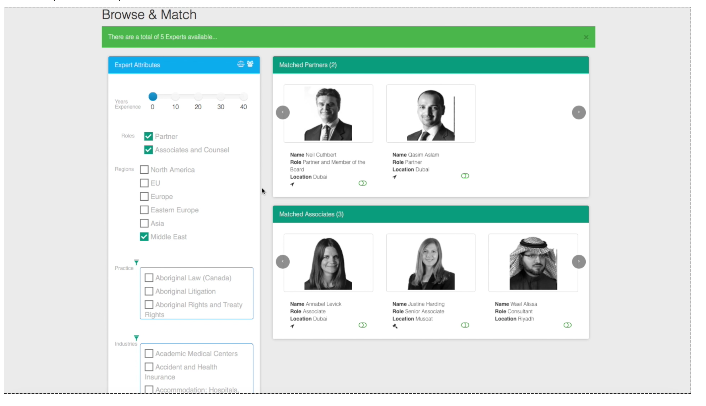

# KPI’s impacted

* Decrease cost of locating expertise
* Increase in response rates
* Increase in employee utilization
* Increase in new business generation
* Decrease in project costs

# Target Buyer

* VP Consulting
* Managing Partner
* VP, Research & Development

## Competitive Differentiation

* Clients often struggle match up resources to project that are about to start based on history and expertise. Watson is uniquely differentiated such that it can serve as the platform that brings together a variety of data sets that help narrow down the right resource for the right project at the right time.

|  |  |  |
| --- | --- | --- |
| Expertise Finder |  | Contact – Owen Coelho – occoelho@us.ibm.com |